Facebook Announces More Ways to Publish to Users Who Click Like Buttons

February 23rd, 2011
Millions of websites and social games have implemented Facebook’s Like button social plugin, yet relatively few are taking advantage of the capability to publish news feed stories to users that click buttons that represent real-world objects. In an effort to increase awareness of this option, Facebook posted to the Developers Blog http://developers.facebook.com/blog/post/465 explaining three ways admins can publish to their Like buttons, including through the new “Use Facebook as Page” feature.
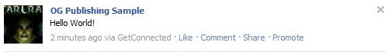
The blog post, and our own conversations with Open Graph page owners, indicate that many web publishers, brands, and game developers don’t know that when users click their Open Graph Like buttons on real-world objects, they’re not only creating a link back to the content on their wall, but are also subscribing to future news feed updates. This option, launched at last year’s f8, http://www.insidefacebook.com/2010/04/29/how-to-programmatically-administer-off-facebook-pages-with-the-open-graph-api/ allows admins to engage a subset of their audience with highly relevant updates.
Note that Like buttons that have the meta tag og:type set to “Article” — those for digital content such as news articles, blog posts, photos, videos, and in some cases, digital representations of retail items — do not have publishing rights and do not appear in the Interests section of a user’s profile.
For instance, film site IMDB has Like buttons on every film, character, actor, and more on their website. It provides news and reviews of a wide variety of films, from family films to horror movies. If the IMDB Facebook Page posted an updated about a new list of top 10 children’s films, only a small part of their audience would find it interesting, while a large portion of their audiences would find the update irrelevant or even spammy, leading them to click the Unlike button.
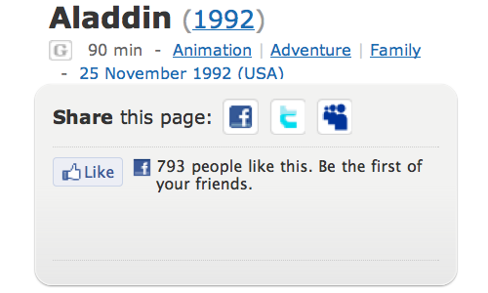
Instead, IMDB could publish the update about family films to only those users who’ve clicked Like buttons on any of their family films. By sending niche-specific updates to those who Like that type of content, IMDB can send higher relevancy updates more frequently but to less people, increasing click through rates and driving more traffic to their website without spamming all 585,000 fans of their Facebook Page.
Previously, admins could publish to their Like buttons on real-world objects programmatically through the Graph API by following the Open Graph page documentation, http://developers.facebook.com/docs/opengraph/ or by clicking the “Admin Page” link that admins see next to the Like buttons on their site or game.
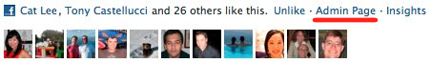
Now, admins can also publish to their Like buttons through the “Use Facebook as Page” option released as part of the 2011 Page redesign http://www.insidefacebook.com/2011/02/10/page-redesign-2011-guide/. By clicking the Account drop-down menu in the top right corner of the Facebook window and selecting “Use Facebook as Page”, or by visiting the Page Manager http://www.facebook.com/pages/manage , admins can select to use Facebook as one of their Like buttons. They can then post updates through the Publisher just as they would with a traditional Facebook Page.
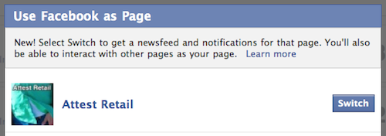
News feed stories published through any of these means will display the name of the Like button’s content, an image and blurb if available, the story’s own Like button.
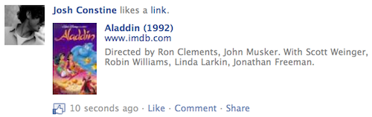
As more admins realize they have this option, users will begin to see more stories in their news feeds from Like buttons they’ve clicked. Any Open Graph Like of a real-world object that has publishing privileges appears in the Interests section of the user’s profile, and from there users can visit the original site and Unlike them if they want.
Open Graph Likes without publishing privileges — those of news articles and other digital content, don’t appear in the profile, and and can only be Unliked from the activity feed post about the original Like, or by visiting the original site.
The option to publish to Like buttons will help users see high-quality niche content about specific pieces of content they care about from across the web.
Update: The original version of this article included a critique of Facebook under the incorrect belief that not all Open Graph Likes with publishing privileges could be managed from the Interests section of the profile. All Likes with publishing privileges do in fact appear in the profile and can be Unliked from there if the user desires. Only Likes of websites with the meta tag og:type “Article”, which don’t have publishing privileges, do not appear in the profile.
Therefore, Facebook has provided adequate Open Graph management options. The mistake stemmed from Urban Outfitter’s use of Like buttons with og:type “Article” on their products, despite them representing real-world objects. There is no additional risk to the quality of a user’s news feed in Liking Open Graph objects than in Liking traditional Facebook Pages. We apologize for the inaccuracy.
URL To study

http://www.huffingtonpost.com/business/

MetaData of 1 of the page on Huffington Post http://www.huffingtonpost.com/news/european-union

<meta name="Title" content="European Union : Pictures, Videos, Breaking News" />
<meta name="Description" content="Big News on European Union. Includes blogs, news, and community conversations about European Union" />
<meta name="Keywords" content="European Union, European, Union" />
<title>European Union : Pictures, Videos, Breaking News</title>
<meta property="og:site_name" content="The Huffington Post"/>
<meta property="fb:app_id" content="46744042133"/>
<meta property="og:type" content="blog"/>
<meta property="og:title" content="European Union" />
<meta property="og:image" content="http://i.huffpost.com/gen/297456/thumbs/s-SOROS-EURO-mini.jpg" />
<meta property="og:url" content="http://www.huffingtonpost.com/news/european-union/" />

http://www.openaudiencemanager.com/about/screens/

http://developers.facebook.com/docs/opengraph/

http://developers.facebook.com/blog/post/397/

How to Programmatically Administer Off-Facebook Pages with the Open Graph API

April 29th, 2010
By Justin Smith | 9 Comments »
With the Open Graph protocol that Facebook announced at last week’s f8 conference, any URL can now be treated just like a Facebook Page http://www.insidefacebook.com/2010/04/21/with-the-open-graph-protocol-any-url-can-be-treated-just-like-a-facebook-page/ . After you mark up your site with the right metadata and encourage users to start Liking your site, you can then publish updates to their Facebook News Feed just like as if your website were an on-Facebook.com Page.
But a good question is: exactly how does a website publish to the Facebook News Feed when it doesn’t exist as a Facebook Page in the first place? Well, the answer is two-fold:
1) First, Facebook said last week that all websites that mark themselves up with the right Open Graph metadata and <fb:admins> tag will actually get an admin interface just like that of Facebook Pages, from which they can publish status updates to fans. At that point, you’d simply have to head over to Facebook to publish status updates.
2) Second, Facebook has also made available a way to associate your Open Graph-enabled site with a Facebook application. By adding the following line to your pages, Facebook will connect your site to an application ID:
<meta property="fb:app_id" content="1234567"/>
Then you’ll need to get the Facebook ID for your page from its canonical URL:
curl 'https://graph.facebook.com/?ids=http://www.imdb.com/title/tt0117500/'
Once you have that ID for your URL, you can publish to users’ streams programmatically using the stream.publish API (though Facebook says a new method is coming “very shortly”).
Ultimately, Facebook hopes that by getting a lot of sites to adopt the Open Graph protocol, it can drive more engagement for publishers by getting them to adopt the News Feed as a more important form of user communication. If it succeeds, Facebook would then become an even more important layer of communications infrastructure as it serves more sites around the web in the same way that it has traditionally just served “Pages” on Facebook.com.

<html xmlns:og="http://opengraphprotocol.org/schema/" xmlns:fb="http://www.facebook.com/2008/fbml">
<head>
<meta property="og:title" content="Co je právě in?"/>
<meta property="og:type" content="website"/>
<meta property="og:url" content="http://www.jein.cz/"/>
<meta property="og:image" content="http://www.jein.cz/images/jein.png"/>
<meta property="fb:admins" content="669384918"/>

property=”fb:admins” content=”admin user FB ID”
<meta property="og:description" content="Co je právě in na českém internetu aneb co se líbí českým uživatelům Facebooku."/>
<meta property="og:email" content="jan.horna@gmail.com"/>

With the Open Graph Protocol, Any URL Can Be Treated Just Like a Facebook Page

April 21st, 2010

By Justin Smith | 37 Comments »
We are here at f8, where Facebook has announced its vision for the “Open Graph,” as well as a new set of plugins (widgets) designed to write to and read from the Graph on any website. Facebook’s Mark Kinsey and Austin Haugen just explained in more detail how publishers, brands, and media companies can use the Open Graph together with the Like plugin and other plugins to get more distribution and engagement across Facebook.
Essentially, by using markup tags specified in the Open Graph protocol, any website can register itself as a unique object in the Facebook ecosystem. If a Facebook user visits your site Likes your page, you then have the ability to publish information into that user’s stream. In addition, you get an administration interface, and Insights metrics tools, just like those of any Facebook Page owner.
Implementation Options
You have the option to implement Facebook’s new Like button with either an XFBML tag or an iframe. The two are exactly the same, except that when you use the XFBML tag, users get the option to add a comment. If the user adds a comment, the action is published in the feed as a full story in the stream; if not, it’s published as a one-line story.
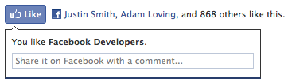
You can also choose how wide you want the widget to be. Facebook will automatically choose profile photo sizes based on what you specify, but you can also hide profile photos, or just show the “Like” button alone (not showing how many people have liked this page overall). There is also a dark version.
Finally, publishers can specify to change the language on the Like button to “Recommend” instead of “Like.” Facebook says this is intended to allow publishers the opportunity to avoid potentially awkward language when wanting to share some types of content with friends that they want to have a conversation about – for example, a news article on a devastating natural disaster.
How to Make Facebook Treat Your URL Just Like a Facebook Page
The most important part brands, business, and publishers should pay attention to is the new “Open Graph protocol.” Essentially, by adding a little bit of HTML markup to your page, you can enable Facebook to read structure metadata about your URL and treat it as a “permanent object” in the Facebook Graph.
This has 3 consequences:
1. You can now communicate with people who Like your URL just like Fan Page owners have historically been able to communicate with fans – publishing updates to their Facebook stream.
You have to go to a Facebook admin page to do this (that happens to look exactly the same as what a traditional Facebook fan Page provides), and there you’ll be able to publish updates to everyone who has liked your URL. You just specify who can see your admin page by adding one of the two following lines of code:
- To assign a list of users as page admins:
<meta property="fb:admins" value="USER_ID1,USER_ID2" />
- To assign this page to a Facebook app:
<meta property="fb:app_id" value="1234567" />
2. You also get all the traditional analytics tools Facebook has historically provided Fan Page owners. Facebook’s new “Insights for Your Domain” shows you the number of people who’ve liked your Page, daily active users (DAU), daily new users, etc.
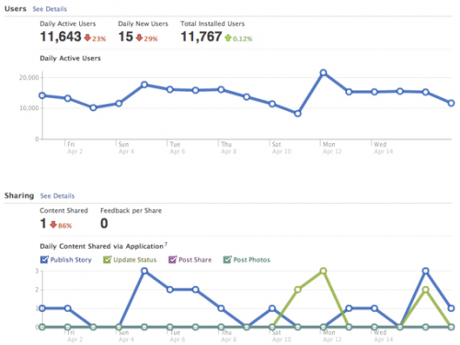
3. When Facebook gets metadata about your URL (when someone likes it), it’s able to categorize it and put it in the right slot on a user’s “Info” tab on the profile, and generally display it in a more rich way whenever it shows up in the stream.
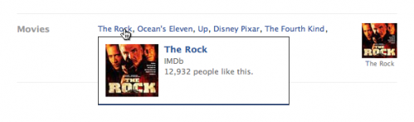
http://wordpress.org/extend/plugins/like/
Hey, if you writing something, write correct values:
Not a
<meta property="fb:admins" value="” />
<meta property="fb:app_id" content="” />
Must be
<meta property="fb:admins" content="” />
<meta property="fb:app_id" content="” />
Atribute “content”, not “value”!

How-To: Publish updates to people who like your Open Graph Page
You can publish stream updates to people who like your page just like you can with Facebook Pages. There are two ways to get to the publishing interface:
- From your Web page, click Admin Page next to the Like button.
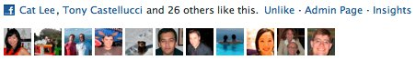
- From Facebook, click "Use Facebook as a Page" under the Account tab or click here.
You can publish stories to people who like your Open Graph Page the same way you write a Facebook post from your own wall. The stories appear in the News Feeds of people who have clicked the Like button on the Open Graph Page.
You can also publish using our API. If you associate your Open Graph Page with a Facebook app using the fb:app_id meta tag, you can publish updates to the users who have liked your pages via the Graph API.
First you need to get an access token for your app. This can be obtained with:
curl -F type=client_credentials \
-F client_id=your_app_id \
-F client_secret=your_app_secret \
https://graph.facebook.com/oauth/access_token
Using this access token and the URL of your page, you can publish to users via the API with:
curl -F 'access_token=...' \
-F 'message=Hello World!' \
-F 'id=http://www.example.com' \
https://graph.facebook.com/feed
Here is some sample PHP code to help you get started:
<?php

$ogurl = "YOUR_OPEN_GRAPH_URL";
$app_id = “YOUR_APP_ID”;
$app_secret = "YOUR_APP_SECRET";

$mymessage = urlencode("Hello World!");

$access_token_url = "https://graph.facebook.com/oauth/access_token";
$parameters = "type=client_credentials&client_id=" .
$app_id . "&client_secret=" . $app_secret;
$access_token = file_get_contents($access_token_url .
"?" . $parameters);

$apprequest_url = "https://graph.facebook.com/feed";
$parameters = "?" . $access_token . "&message=" .
$mymessage . "&id=" . $ogurl . "&method=post";
$myurl = $apprequest_url . $parameters;

$result = file_get_contents($myurl);
echo "post_id" . $result;

?>
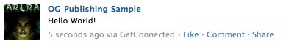
The story will be published with the attribution of your app name (e.g., “GetConnected”).
See our documentation https://developers.facebook.com/docs/opengraph/#publishing for more info.

Facebook Page Redesign 2011: All You Need to Know

February 10th, 2011
Today Facebook launches a major redesign and expansion of functionality of its Pages for businesses, brands, media, and public figures. The Page layout will now match the December user profile redesign, with a left-hand navigation menu replacing the tabs above the wall. Page admins will also be able to login as their Page, giving them access to Facebook and email notifications about activity on their Page, and other options.
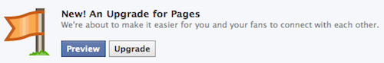
Page admins will begin seeing a preview and tour of the new features today, and will have the choice to voluntarily upgrade until March 1st when all Pages will be automatically migrated to the redesign.
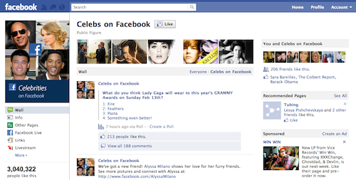

New Layout
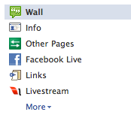
Users now navigate between a Page’s wall, info, and third-party tab applications using a menu of links on the left side of the Page beneath the profile picture. The menu permits longer tab names and between eight and nine tab apps above the fold. To reorder tabs, click “More”, then “Edit” and drag and drop any of your tabs except “Wall” and “Info”. Only Pages with more tabs than spaces above the fold can edit the order of their tabs.
As tabs are no longer front-and-center, the redesign could reduce the frequency with which users visits tabs other than the default landing tab.
Similar to the redesigned user profile, Pages have a Photostrip above the wall that displays the latest photos the Page has tagged itself in. However, the five thumbnails appear in a different order upon each reload, preventing Pages from creating a continuous banner out of the Photostrip. The profile picture is slightly reduced in size from 200 x 600 pixels to 180 x 540. The About blurb has moved from the wall tab to the info tab.
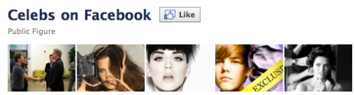
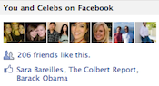
Users will see a mutual friends and interests panel on the top right displaying the friends who also Like the Page, and the Likes the user and the Page have in common. Pages will have the option to Like other Pages, not just favorite them, and feature “Page Owners”. Links and profile pics of these Likes and admins can be made visible below the navigation menu and reordered through the new “Featured” section of the Edit Page admin interface.
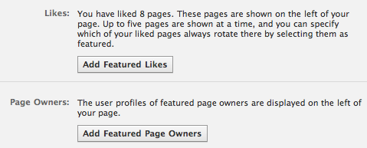
When Pages update, their default landing tab will be reset. Admins should be sure to reselect the tab they want visitors who haven’t Liked their Page to see first. If Pages use a welcome tab with some sort of arrow pointing to the Like button at the top of the Page, they’ll need to modify the tab’s design as the Like button has moved slightly.
Admins can edit their Page’s category by going to the Basic Information tab of the Edit Page admin interface.

Relevant Posts Wall Filter
Page admins can select between an “All Posts” and a Page posts only default tab for the wall. All Posts is broken up into “Top Posts” and “Most Recent” tabs.
Top Posts, which displays first when All Posts is set as the default view, shows users posts Facebook thinks will be the most relevant. Recent posts by friends, posts by other users in same language or country, and posts that have received a lot of Likes and comments will bubble to the top.
Most Recent shows a reverse chronological, real-time stream of posts by the Page and its fans. Users can click to view Most Recent when viewing Top Posts, but admins can’t set Most Recent as the default view.
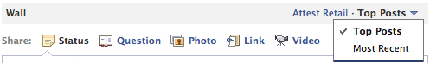
Users will see a Page’s wall display the same tab as it last showed. So if they switch from Top Posts to Most Recent, leave the site, then come back, they’ll still see the wall display the Most Recent tab. This persistent wall state works the same way as the Top News and Most Recent tabs for the news feed, which similarly maintain state between visits.
Admins can click the “Hidden Posts” link beneath wall in the navigation menu to view a feed of posts they or Facebook’s spam detectors have filtered out of public view. Admins can select to unhide posts from this feed.
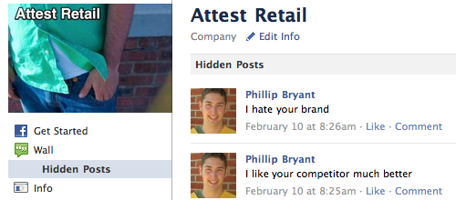

Admins Can “Use Facebook as Page”
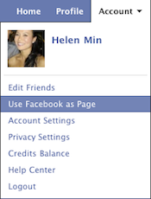
Page admins can choose to “Use Facebook as Page” from the Account drop-down menu in the top right corner of Facebook. Admins will then see a special version of the site chrome where they can post and comment around the site under their Page’s alias, though not on user profiles a Pages can’t have friends. Since Pages can now Like other Pages, admins see a news feed of updates from Liked Pages.
The notifications drop-down in the top navigation bar shows the latest user posts and comments to the Page the admin is using. The friend request drop-down shows how many Likes their Page has received since the admin last used the site as their Page.
In response to frequent requests, Facebook admins can now turn on email notifications to alert them to activity on their Page through the “Your Settings” tab of the Edit Page admin interface. These emails could be overwhelming for popular Pages that receive thousands of posts and comments a day, but will certainly help smaller Pages stay attentive to their fan community. Hence, smaller Pages default to having notifications turned on, while larger Pages default to off.
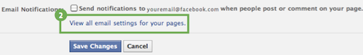

Developers: No API Changes, but Tab Apps Can Now Use Iframes
The Page redesign does not affect the Page APIs, so developers don’t need to worry about their applications breaking. The expanded tab name space in the new navigation menu means developers can try using longer, more descriptive titles for when their application is installed as tab.
However, the Facebook Developers Blog has just announced that Pages can finally feature iFrame tab applications. Facebook announced the option in August as being slated for Q4 2010, but today says it has postponed the implementation until March 11, 2011. We’ll have more details in a forthcoming post.
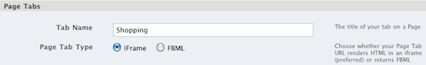
Some Pages and Places briefly experienced a bug that caused the width of their tab applications to be smaller than it should be, cutting off the right edge of the app. Facebook has now fixed this bug.

An Upgrade, Not Just a Redesign
As users have grown familiar with the new profile over the last two months, it should be easy for them to acclimate to this redesign, which was accidentally pushed live for a few minutes in December. As well as creating a more consistent browsing experience, Facebook has granted many requests from the Page admin community. The only potential downside is that the less prominent placement of links to tabs could reduce their use.
Of all the beneficial changes, the Top Posts wall filter in particular will make sure users see high quality content each time they visit a Page. This will bolster confidence in brands and businesses that users directed to their Page will have an enjoyable, engaging experience. This will in turn lead them to spend more on Facebook ads that drive traffic to their Pages, generating more revenue for Facebook.
Page admins looking for updated best practices for the redesign should see the Facebook Marketing Bible, Inside Network’s comprehensive guide to brand marketing on Facebook.
Update 3/2/2011: Facebook has made several changes to Pages since the redesign, including providing a reverse chronological “Most Recent” view of the Page wall, which some admins requested. It has also increased the number of Page tab apps that appear above the fold in the navigation menu.

